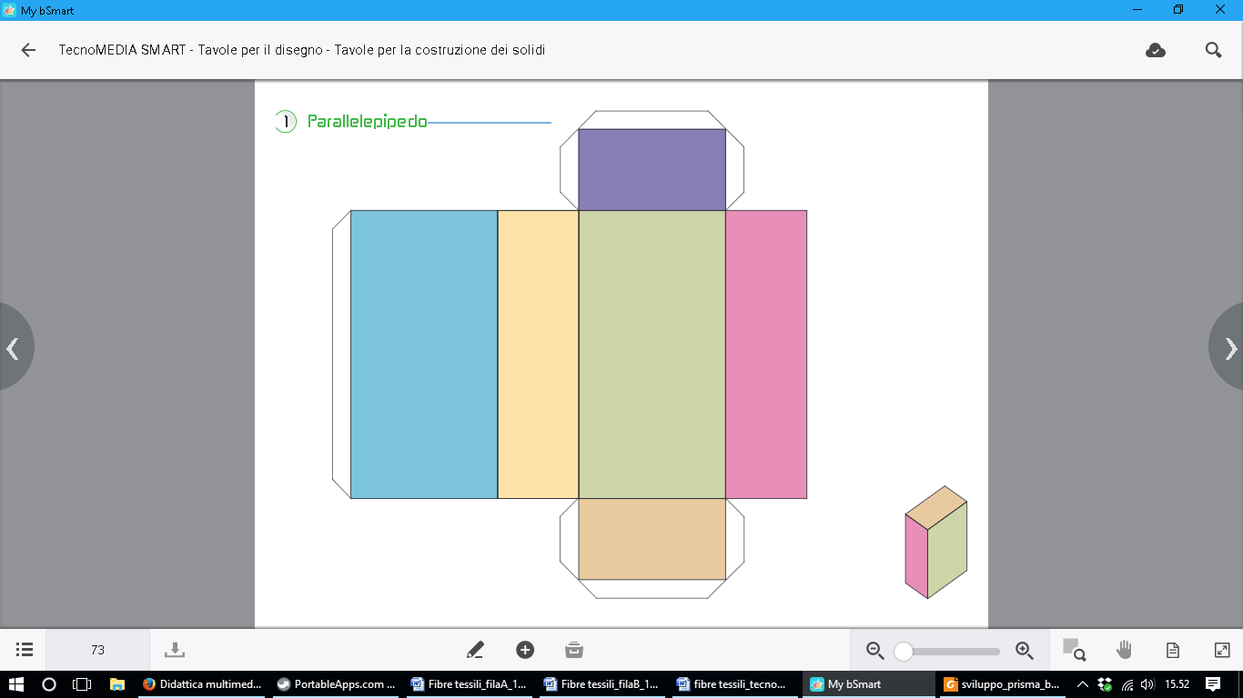

H

G

F

E

AB = 5 cm

BC = 3 cm

CG = 8 cm

D

C

B

A